Justin Slade

G00409678

CS 435

Fall 2024

Big Data & Cloud Security

AWS Lab Report 1

Date: 10/25/2024

Grambling State University

Big Data and Cloud Security

**Purpose or Objective:** Learn how to utilize Athena and AWS Glues to gather information stored within an Amazon S3 bucket.

**Procedure/s:**

* Using Athena to create AWS Glue database and table
* Define AWS Glue database
* Configure Athena to communicate with Amazon S3 buckets
* Create views with Athena for more readable data

**Task 1.**

I need to create an AWS Glue database using Athena.

I First had to make my way to the Athena console and tell it to look into a specific S3 bucket for this lab. After this I needed to create a database to allow me the ability to query data from said S3 bucket.

After following some instructions. I was able to locate the S3 bucket location and have it connected to my table and also mass generated some tables that included some default meta data. This screenshot is a set of instructions for SQL to make the table.

**Task 2.**

Now I need to optimize Athena to utilize an Amazon S3 bucket

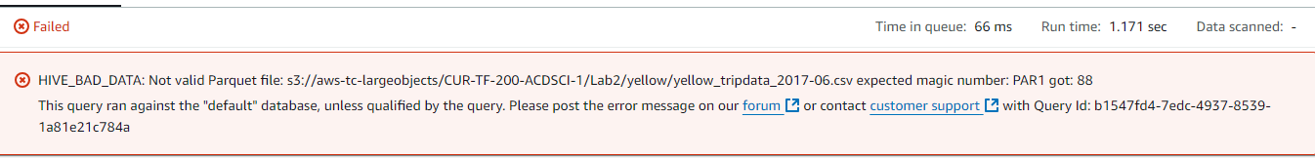

**Unfortunately My lab is bugged so I can’t continue the lab. I will try to do this later, but unfortunately making a database under taxi data will not get the SQL to run since it stating it cant find it.**

**Conclusions:**

My lab isn’t working unfortunately I will try again later after the deadline. I tried 4 times to get this lab to work wasting an hour to attempt to get it to work.

**Knowledge Check (7) Screenshot:**

